Rudra Chinhara
Write a function POWER( ) which raises a number m to a power n. The function takes a double value of m and an integer value of n and returns the result. Use a default value of n is 2 to make the function calculate squares when this argument is omitted.

Power Function
CODE
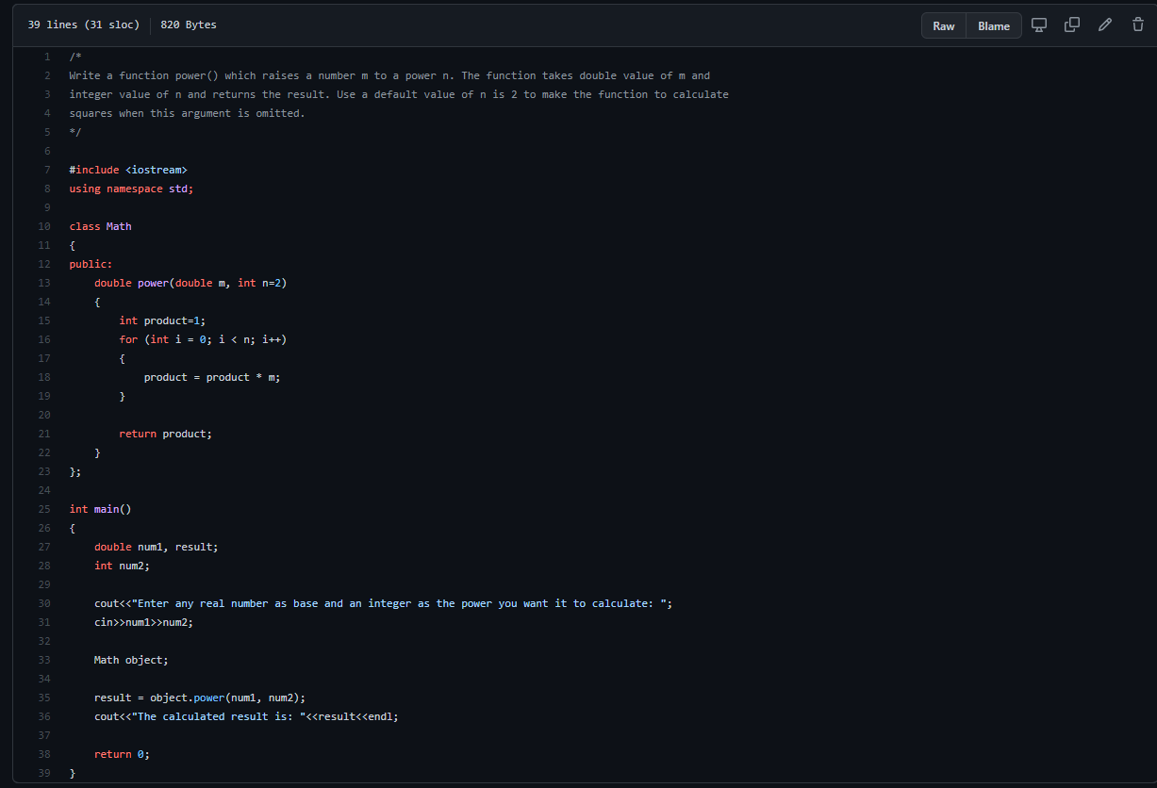

OUTPUT

GitHub Link

